Running Head: UNDERLYING MECHANISMS IN AFFECT VALUATION

The Effects of Interpersonal Goals on Affect Valuation

Felicity F. Miao
Stanford University

Abstract
Previous studies suggest that Chinese culture values calm and other low activation positive emotions, while American culture values excitement and other high activation positive emotions (Tsai & Knutson, 2004). This study sought to examine whether these cultural differences are related to cultural differences in interpersonal goals of influence and adjustment. Fifteen European American and 15 Asian American same-ethnicity female dyads participated in a joint picture-matching task. Within each dyad, partners were either assigned to be “Leaders” (e.g. influence their partner) or “Matchers” (e.g. adjust to partner). As predicted, across ethnic groups, Leaders valued high activation positive emotions more and low activation emotions less. These findings suggest that 1) affect valuation can be situationally manipulated, and 2) cultural differences in affect valuation may be due to cultural difference in interpersonal goals.

The Effects of Interpersonal Goals on Affect Valuation
Recent studies suggest that cultures vary in their affect valuation, or the affective states that people value and would ideally like to feel (“ideal” emotions) (Tsai & Knutson, 2004). Specifically, Chinese cultures value calm, peacefulness and other low activation positive (LAP) emotions, while North American cultures value excitement, enthusiasm and other high activation positive (HAP) emotions. Tsai and Knutson (2004) have proposed that cultural variation in affect valuation may be due to cultural ideas and practices, particularly those related to individualism and collectivism. In fact, Tsai and Knutson (2004) observed that regardless of one’s cultural group, individualistic values (e.g. self-direction) are highly correlated with valuing HAP, while collectivistic values (e.g. tradition) are highly correlated with valuing LAP. Similarly, individuals with independent self-construals value HAP, while individuals with interdependent self-construals value LAP (Tsai & Knutson, 2004).
These studies, however, have not identified the specific aspects of individualism and collectivism that account for observed differences in affect valuation, nor do they address the causality of the relationship between individualism-collectivism and affect valuation. We propose that cultural variation in interpersonal goals may account for cultural differences in affect valuation. Several scholars have argued that while East Asian cultures emphasize “adjustment” goals (or low agency) such as belonging or fitting in with one’s group, knowing one’s place, maintaining harmony with others, and putting others’ needs before one’s own (e.g. Markus & Kitayama, 1991). In contrast, North American cultures emphasize “influence” goals (or high agency) such as having a positive impact on others, being respected by others and expressing oneself. For example, when asked to recall times when they influenced or adjusted to others, American participants remembered more influence situations, whereas Japanese participants remembered more adjustment situations (Morling, Kitayama & Miyamoto, 2002).
Weisz, Rothbaum and Blackburn (1984) argue that these cultural differences are due to childrearing practices, religious and philosophical influences. Japanese children are reared in close proximity to their family that seems to foster attentiveness to others. On the other hand, American children are reared to be autonomous from the family that seems to foster self-expression. Likewise, the religious and philosophical traditions in both cultural contexts reflect cultural differences in interpersonal goals. In the United States, the predominant religion of Christianity emphasizes that the self needs to alter the world. Many instances of this can be found in the Bible and also in the missionary ventures that Christians invest in. In Japan, there are multiple faiths that are dominant but Zen Buddhism is an example of a faith that has shaped the history, traditions and culture of Japan. Zen Buddhism adherents are trained not to attempt to influence existing realities, but instead to accept the ways things are.
We argue that these differences in interpersonal goals may result in different ideal emotional states. High agency goals (e.g. wanting to be respected by others) are related to valuing HAP while low agency goals (e.g. putting others needs before one’s own) are related to valuing LAP (Tsai & Knutson, 2004). Because influencing and acting on others require high arousal, individuals with influence goals should value HAP. Adjusting to others, on the other hand, requires paying attention to others needs and preparing to act in a way that is consistent with others’ needs, which require low arousal states. These individuals with adjustment goals should value LAP.

The Present Study
To test the hypothesis that interpersonal goals of influence and adjustment would be related to affect valuation, I manipulated the interpersonal goals of European Americans (EA) and Asian Americans (AA). I predicted that across groups, individuals with influence goals would value HAP (excitement) more and LAP (calm) less than people with adjustment goals.

Method

Participants
Thirty European American (EA) and 30 Asian American (AA) female university students participated in a study of “mood and puzzle solving.” Participants were recruited via email distribution lists and were paid $15 for their participation. The mean age of participants was 20.03 (SD = 1.70), with no significant differences in age between groups.
Participants were first screened to ensure that they met the study criteria. All participants were required to be proficient in English. EA were required to: (a) have been born and raised in the United States, (b) have parents who were born and raised in the United States, and (c) be of European ancestry (on both sides of their families). AA were required to: (a) have been born and raised in the United States or in a East Asian country (e.g. China, Hong Kong, Taiwan, Japan, Korea), and (b) have parents who were born and raised in an East Asian country. If participants fit these criteria, they were invited to participate in the study.

Procedure
There were two parts to this study, an experimental session and an Internet survey. The first part required participants to come into the laboratory for a study of mood and puzzle solving. Participants were run in same-ethnicity dyads. Upon arrival to the laboratory, the experimenter first verified that the two participants were not acquainted with each other and then seated them opposite one another with a table between them. In the middle of the table there was a screen that prevented both participants from seeing each other’s stimuli. Participants read and signed the consent form, and were then randomly assigned to one of two conditions. To show participants that assignment was truly random, two pieces of paper were shown. One said “Leader” (person with influence goals) and the other said “Matcher” (person with adjustment goals). The pieces of paper were then put inside a bowl. Before picking out a piece of paper, the experimenter made it clear to the dyad which person would get the role as indicated on the paper (this was always the participant to the right of the experimenter).

Joint picture-matching task.
This task was modeled after a communication task designed by Schober and Clark (1989). The stimuli provided to both participants were exactly the same and comprised a set of 16 cards, each displaying a different figure on it (see Figure 1) arranged randomly in a 4x4 square. Each participant was provided with a clipboard containing a sorting frame with 12 square spaces numbered from 1 to 12 (to help organize their cards).
The Leader was told that she had to first come up with an order that made sense to her for 12 of the 16 figures before verbally describing them to the Matcher. The Matcher’s task was to place her figures in the same order as the Leader. Both participants were told that they should work as quickly and accurately as possible. Although the Leader was allowed to verbally describe the cards in whatever way she chose, the Matcher was told that she could only hold up the card when she thought she had identified the correct one. While there were no limits on how many times the Matcher could hold up a card to the Leader for correctness, the Matcher was told to minimize the number of times she held up a card. (See Appendix for script.) This experimental task lasted for approximately 10 minutes.
After the two participants successfully matched 9 of the 12 figures, the experimenter asked them to complete measures of “ideal” and “real” affect. We administered these measures in the middle of the task to ensure that the participants had not yet completed the task, but were engaged. After the participants completed the measures of ideal and real affect, they finished the task and were then given a questionnaire packet to complete. This packet contained the following measures: (in this order) Circumplex Scales of Interpersonal Values (CSIV), and a demographics form.
Web survey.
The second part of the study involved contacting participants via email approximately one week following their participation in the laboratory. Participants were asked to complete a second set of questionnaires (global real and ideal affect, and global CSIV) via the Internet. These measures were administered to assess whether AA and EA participants differed in global ideal affect, as suggested by previous work by Tsai and Knutson (2004). This set of questionnaires took approximately 12 minutes to complete.

Instruments

Affect Valuation Index.
The Affect Valuation Index (AVI; Tsai & Knutson, 2004) has been shown to be both a reliable and valid measure of ideal affect for American and Chinese college students. The index asks participants to “rate how much you would IDEALLY like to feel” each of the 28 feelings and emotions “on average”, using a scale from 1 = not at all, to 5 = extremely. For the first step in this study, participants were asked complete a slightly different version of the AVI; “rate how much you would IDEALLY like to feel” each emotion “right now”. This ideal affect measure used 17 of the 28 AVI items; in addition, 7 new affect terms were added that were particularly relevant to the experimental task (new HAP terms: motivating, lively, energetic, eager; new LAP terms: harmonious, at ease, composed), making a total of 24 (see Table 1). While all octants of the affective circumplex (Watson & Tellegen, 1985) were sampled, we over-sampled the HAP and LAP octants because these were the octants for which we had specific hypotheses. Mean aggregates were created for items in the same octant. In the current study, internal consistency estimates were high for both ideal HAP and LAP (.87 and .91 for the entire sample, .86 and .91 for EA, and .87 and .88 for AA).
A parallel version of the ideal affect measure was administered to assess real affect. Participants were asked to rate how they actually felt the same items listed in the ideal affect measure. Again, mean aggregates were created for items in the same octant, and internal consistency estimates were high. (Real HAP and LAP were .90 and .87 for the entire sample, .88 and .87 for EA, and .91 and .88 for AA.)
One week following the experimental task, participants were contacted again to fill out measures of global real and ideal affect. Specifically, participants were asked “how much do you TYPICALLY feel each of the following feelings and emotions” for real affect, and “how much would you IDEALLY like to feel each of the following feelings and emotions on AVERAGE” for ideal affect. Internal consistency estimates for global ideal HAP and LAP were .81 and .86 for the entire sample, .73 and .77 for EA, and .85 and .91 for AA. Internal consistency estimates for global real HAP and LAP were .81 and .92 for the entire sample, .75 and .90 for EA, and .87 and .94 for AA.

Interpersonal goals.
To examine the relationship between influence and adjustment goals and affect valuation, the Circumplex of Interpersonal Values (CSIV; Locke, 2000) was administered. The CSIV assesses interpersonal goals related to agency (dominance, power, status) and communion (friendliness, warmth, love). We define influence goals as high agency goals and adjustment goals as low agency goals. This measure also served as a manipulation check for the experimental manipulation. Immediately following the experimental task in the first part of the study, participants were asked to “indicate HOW IMPORTANT it was to you that you acted or appeared, or were treated in the indicated way” by their partners, using a scale ranging from 0 = not at all to 4 = extremely. Internal consistency estimates were high for influence goals (high agency) and adjustment goals (low agency) and were .81 and .87 for the entire sample, .78 to .84 for EA, and .83 to .89 for AA.
The CSIV was administered again in the second part of the study (one week following participation in the experimental task) to assess global interpersonal values, with slightly altered instructions that read “indicate how important it is to you that you act or appear, or are treated in the indicated way when you are with people whom you like and with whom you feel connected”. Internal consistency estimates for influence and adjustment goals were .83 and.84 for the entire sample, .82 to .85 for EA, and .84 to .83 for AA.

Results
First, I present analyses that examine the effectiveness of the manipulation. Second, I present analyses that examine the effects of manipulating interpersonal goals on affect valuation. I predicted that for both ethnic groups, EA and AA, individuals with influence goals would value HAP (excitement) more and LAP (calm) less than individuals with adjustment goals. Finally, I present analyses that examine whether previously observed differences in affect valuation between the two samples (EA and AA) held for the present sample.
All analyses (with the exception of correlational analyses) used ipsatized scores (each participants’ responses was standardized according to how each rating scale was used).

Did The Manipulation Work?
To verify that the experimental manipulation for influence and adjustment worked, a 2 Group (EA, AA) X 2 Role (Leader, Matcher) X 2 Goal (influence, adjustment) repeated measures of variance was conducted, with Group as a between-subjects factor and Role and Goal as within-subjects factors. Consistent with predictions, analyses revealed a significant Role X Goal crossover interaction, (F[1,28] = 42.91, p<.001). See Figure 2 for means and SD.
Follow-up 2 comparisons revealed that Leaders endorse influence goals more than Matchers (F[1,28] = 43.83, p<.001), while Matchers endorsed more adjustment goals than Leaders (F[1,28] = 35.71, p<.001). Moreover, Matchers endorsed adjustment goals more than influence goals (F[1,28] = 40.29, p<.001) and Leaders endorsed influence goals more than adjustment goals, although this difference was only marginally significant (F[1,28] = 3.26, p = .08). Thus, the manipulation was effective in eliciting influence and adjustment goals.

Are Influence and Adjustment Goals Related to Ideal HAP and LAP?
To test our hypothesis that interpersonal goals about the relationship between interpersonal goals and affect valuation, we conducted a 2 Group (EA, AA) X 2 Role (Leader, Matcher) X 2 Emotion (ideal HAP, ideal LAP) repeated measures analysis of variance, with Group as a between-subjects factor, and Role and Emotion as within-subjects factors. Consistent with our predictions, there was a significant Role X Emotion crossover interaction (F[1, 28] = 9.27, p<.01). See Figure 3 for means and SDs. No significant main effects or interactions of Group emerged.
As predicted, follow-up analyses revealed a significant main effect of Role for both ideal HAP and LAP (ideal HAP: F[1,28] = 6.93, p<.05; ideal LAP: F[1,28] = 9.68, p<.01). Leaders valued HAP more and valued LAP less than Matchers. Matchers also valued LAP more than they valued HAP (F[1,28] = 16.28, p<.001).
2 Group (EA, AA) X 2 Role (Leader, Matcher) analyses of variance were conducted on the remaining 6 octants of the affective circumplex. A significant Group X Role interaction emerged for ideal high activation (HA; e.g. aroused) emotions where EA Leaders valued HA more than EA Matchers and AA Matchers valued HA more than AA Leaders.
Associations between interpersonal goals and ideal affect were also examined with partial correlational analyses, controlling for real affect. Both ideal HAP and influence goals were positively correlated. Similarly, ideal LAP and adjustment goals were also positively correlated. See Table 3 for correlation coefficients.
Thus, as predicted, across ethnic groups, Leaders valued HAP more than Matchers, and Matchers valued LAP more than Leaders.

Were There Differences in Real Affect?
To examine whether interpersonal goals affected real affect, we conducted a 2 Group (EA, AA) X 2 Role (Leader, Matcher) X 2 Emotion (real HAP, real LAP) repeated measures analysis of covariance, controlling for ideal affect. No significant main effects or interactions were found for real affect. Thus, the differences in ideal affect were not due to differences in real affect.

Were there Ethnic or Role Differences in Global Ideal Affect and Global Interpersonal Goals?
The CSIV and real and ideal affect measures were administered one week after the experimental task to test for 1) whether random assignment to conditions was successful, and 2) whether previously observed cultural differences in affect valuation held for the present sample, which was particularly important because no significant main effects or interactions involving ethnicity were found in ideal affect.
Random assignment was successful.
One-way analyses of variance revealed no role differences in participants’ endorsement of influence and adjustment goals, nor in ideal HAP and ideal LAP.

AA value LAP more than EA.
Consistent with previous findings, a one-way analysis of covariance, controlling for real affect, revealed significant differences in global ideal LAP between the two groups. AA value LAP more than EA (F[1,48] = 4.17, p<.05). Also consistent with previous findings, no differences in ideal HAP were found between the EA and AA.

Discussion
In sum, the manipulation was effective in eliciting influence and adjustment goals that led to predicted changes in affect valuation. Influence goals were related to HAP while adjustment goals were related to LAP. Overall, the study provides empirical support for the hypothesis that interpersonal goals of influence and adjustment are related to ideal HAP and LAP. These findings also lend support to the hypothesis that cultural differences in affect valuation are due to cultural differences in interpersonal goals.
Interestingly, the manipulation appears to have been stronger for Matchers than for Leaders. Matchers endorsed adjustment goals more compared than influence goals and more than Leaders. The same pattern of results emerged for ideal affect. Matchers not only valued LAP more than HAP, but also valued LAP more than Leaders. Leaders, on the other hand, endorsed influence goals more than Matchers, but their endorsement of influence goals over adjustment goals only approached significance. Furthermore, Leaders valued HAP more than Matchers, but valued HAP and LAP equally. In future studies, the manipulation could be made stronger for the Leaders by allowing Leaders to exhibit more influence. For example, Leaders may be more punitive when Matchers do not show the correct card.

Limitations and Future Directions
The present study has some limitations. First, a bigger sample may help to better identify the relationships between variables. The small sample size was particularly problematic with correlations and also for analysis of covariance analyses that involved several covariates. Second, the current study only focused on females. An alternative manipulation design may be necessary for males, as it has been shown that the meaning of groups varies between females and males. Females have been shown to focus more on the relational aspects of interdependence, while males have been shown to focus more on the collective aspects of interdependence (Gabriel & Gardner, 1999). Third, the current study needs to be taken to other cultural contexts (e.g. Hong Kong and Beijing, China) to see if the manipulation can be replicated in non-American contexts.
There are also a number of interesting future research questions now that we have successfully manipulated interpersonal goals and consequently ideal HAP and LAP emotions. In the current study, we gave explicit instructions to the participants about how they should behave in the manipulation. In contrast, it would be interesting to manipulate implicit interpersonal goals in order to assess whether the explicit interpersonal goals were the result of demand characteristics from the task. Also in the current study, manipulation of interpersonal goals was in the context of an ingroup. Participants were told they will work together on the task, thereby creating an ingroup situation for both participants. As the current study shows ideal positive emotions such as ideal HAP and LAP can be manipulated, it would be interesting to manipulate ideal negative emotions on the other side of the affective circumplex such as ideal fear and hostility (ideal High Activation Negative; ideal HAN), or ideal dullness and sluggishness (ideal Low Activation Negative, ideal LAN) by manipulating influence and adjustment goals in the context of outgroup members.

Implications and Conclusion
The findings reveal that ideal HAP and LAP emotions may vary situationally and can indeed be manipulated by manipulating interpersonal goals of influence and adjustment. Furthermore, these data lend support to the theory that cultural differences in affect valuation may be due to cultural variation in affect valuation. At a broader level, the findings also lend support for the theory that interdependent and independent selves can and do coexist in individuals (Cross & Markus, 1991; Gardner, Gabriel & Lee, 1999; Trafimow, Triandis & Goto, 1991; Triandis, 1989). While chronic views of the self are accessible most of the time, situational demands may activate different interpersonal goals which in turn cause us to value different affective states.

References
Cross, S. E. & Markus, H. R. (1991, August). Cultural adaptation and the self: Self-construal, coping, and stress. Paper presented at the annual meeting of the American Psychological Association, San Francisco.
Gabriel, S. Gardner, W. L. (1999). Are there “his” and “hers” types of interdependence? The implications of gender differences in collective versus relational interdependence for affect, behavior and cognition. Journal of Personality and Social Psychology, 77(3), 642-655.
Gardner, W. L., Gabriel, S., & Lee, A. Y. (1999). “I” value freedom, but “we” value relationships: Self-construal priming mirrors cultural differences in judgement. Psychological Science, 10(4), 321-326.
Kitayama, S., Markus, H. R. Kurokawa, M. (2000). Culture, emotion, and well-being: Good feelings in Japan and the United States. Cognition & Emotion, 14(1), 93-124.
Locke, K. D. (2000). Circumplex scales of interpersonal values: Reliability, validity, and applicability to interpersonal problems and personality disorders. Journal of Personality Assessment, 75(2), 249-267.
Markus, H. R. & Kitayama, S. (1991). Culture and the self: Implications for cognition, emotion, and motivation. Psychological Review, 98(2), 224-253.
Schober, M. F. & Clark, H.H. (1989). Understanding by addressees and overhearers. Cognitive Psychology, 21, 211-232.
Trafimow, D., Triandis, H.C., & Goto, S. G. (1991). Some tests of the distinction between the private self and the collective self. Journal of Personality and Social Psychology, 60, 649-655.
Triandis, H. C. (1989). The self and social behaviour in differing cultural contexts. Psychological Review, 96, 506-520.
Tsai, J. L. & Knutson, B. (2004). Affect valuation: Theory, measurement, and cultural variation. Manuscript in Preparation.
Watson, D., & Tellegen, A. (1985). Toward a consensual structure of mood. Psychological Bulletin, 98, 219-235.
Weisz, J. R., Rothbaum, F. M., & Blackburn, T. C. (1984). Standing out and standing in: The psychology of control in America and Japan. American Psychologist, 39(9), 955-969.

Acknowledgements
First and foremost I would like to thank my advisor Jeanne Tsai for her unwavering support. Without her constant encouragement and advice this would have been impossible. I would also like to thank the members of the Culture and Emotion Lab. They have aided me in many ways and I am deeply grateful for the opportunity of working with such inspiring colleagues. Special thanks goes to Elena Sherman who spent many hours on data entry.
This research described in this thesis was supported by a Undergraduate Research Opportunity Small Grant offered by Undergraduate Research Programs, Stanford University, and also by an Undergraduate Research Grant offered by Psi Chi, the National Honor Society in Psychology.

Appendix
Experimental Script

You each have a set of 16 tangram figures and a sorting frame in front of you. Your goal is to both end up with 12 of these figures in the same order on the sorting frame. That is, the tangram figure that appears in your first box (point to sorting frame on the right) should also appear in your first box (point to the sorting frame on the left). In order to accomplish this, each of you will have a different role. One of you will be the leader, and the other one of you will be the matcher. I will explain shortly what these roles mean. But let's first assign those roles now. (Show participants two cards, one with “leader” printed on it and another with “matcher”. Fold these cards into squares and then toss inside bowl. Before picking one out, tell participant to the right that the picked card will be her role, and then tell the participant to the left that the remaining role will be here role.)
(Turn to leader.) As the leader, you will choose 12 tangram figures and decide how to order them. Choose an order than makes most sense to you. Once you have decided on the order of the tangram figures, your job will be to describe verbally each tangram figure to the matcher, so that she can come up with the order in which you have put your tangram figures. (Pause.) When the matcher thinks she knows which figure you are describing, she will hold up the figure. At that point, you can tell the matcher whether or not she is correct. If she chooses the incorrect figure, you should redescribe the figure. Do you have any questions?
(Turn to matcher.) As the matcher, your job is to try to put your tangram figures in the same order as the leader’s tangram figures. You should try to figure out which tangram figure the leader is describing. Keep in mind that the leader has placed the tangram figures in an order that makes the most sense to her. So, it might be helpful to try to think about the leader’s frame of mind when you’re trying to figure out what tangram figure she’s describing. If the description the leader gives you is unclear, you may ask the leader to clarify her description by saying “can you clarify your description?”. When you are certain you know which tangram figure the leader is describing, you should hold the tangram figure above the screen so that the leader can tell you whether or not you have the correct figure. Don’t hold up a figure until you’re fairly certain. If you are wrong, the leader will redescribe the figure again for you. Do you have any questions?
(Turn to both participants.) You will not be under any time pressure in working on this task. However, we would like you to be efficient and work as quickly and as accurately as possible.
So let’s review. As the leader, you should first choose 12 tangrams figures and then put them in an order that makes the most sense to you. Next, you should verbally describe each tangram figure so that the matcher can put them in the same order as you have them. As the matcher, you should use the descriptions from the leader to help you put the tangram figures in her order. You can only ask the leader to clarify her description. Once you’re fairly certain you know which tangram figure the leader is describing you can hold up the tangram figure to show the leader. If you don’t show the right tangram figure, the leader will redescribe the figure again for you.
Table 1. Affect Terms Used in Study
Octant | Abbreviation | Items
High Activation Positive | HAP | Energetic, Excited, Enthusiastic, Lively, Motivating, Eager
Positive | P | Happy, Content
Low Activation Positive | LAP | Calm, Peaceful, Harmonious, Relaxed, At Ease, Composed
Low Activation | LA | Quiet, Still
Low Activation Negative | LAN | Dull, Sleepy, Sluggish
Negative | N | Sad
High Activation Negative | HAN | Fearful, Hostile, Nervous
High Activation | HA | Aroused

Table 2. Means and SD for Influence and Adjustment Goals
 | EA |  | AA
 | Ipsatized | Raw | Ipsatized | Raw
Influence Goals | .03 (.38) | 2.07 (.53) | .09 (.29) | 2.03 (.53)
Adjustment Goals | -.00 (.43) | 1.62 (.62) | -.08 (.31) | 1.83 (.62)

Table 3. Correlations between Interpersonal Goals and Affect Valuation
 | Ideal
 | HAP | LAP
Influence Goals | .24* | .17
Adjustment Goals | .05 | .26*
Note. * p<.05; Hypothesized correlations in bold.
Figure Captions
- Stimuli Used in Manipulation
- Leaders and Matchers Differ in Their Agency During Manipulation
- Leaders and Matchers Value Different Emotions During Manipulation
Figures
Figure 1
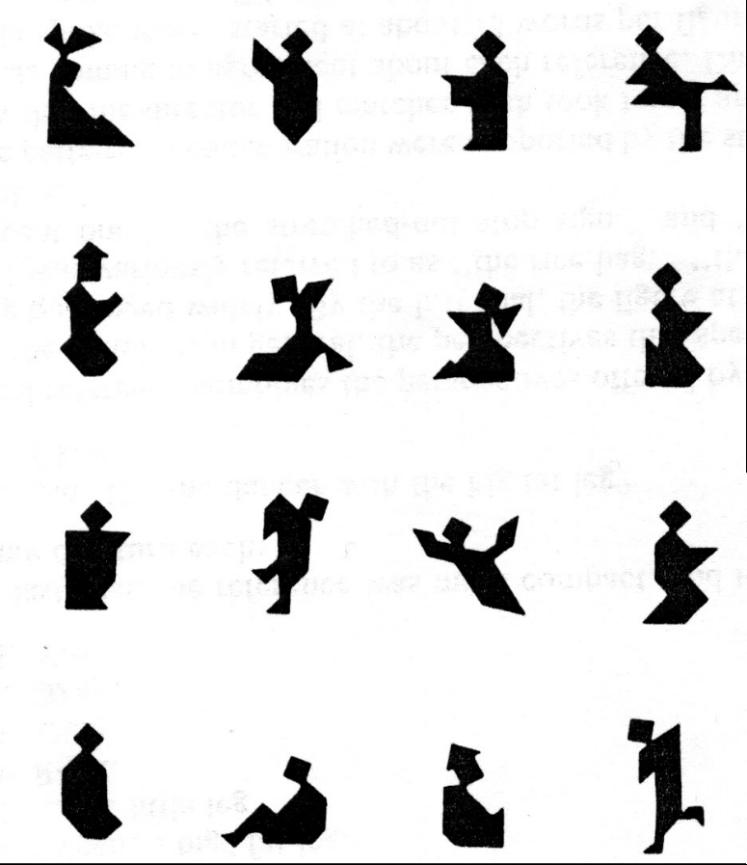

Figure 2
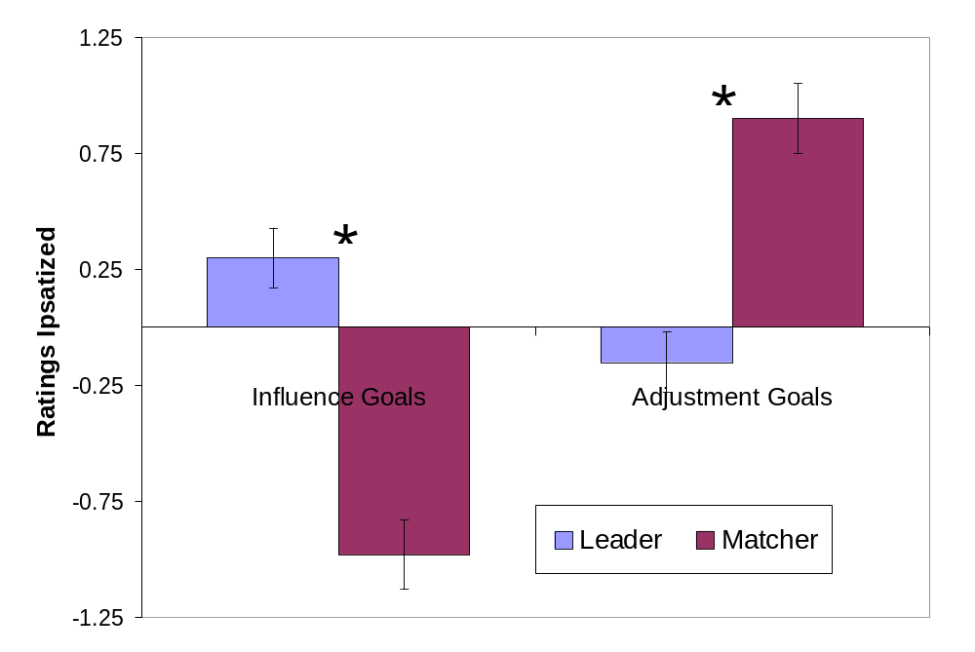
Figure 3
